The search for the form of forms: Looking for a visual "AUM" .I Hidden dimensions

Hilary Shames

Private, Ambridge PA

Introduction
It has been said that our senses perceive only one percent of reality. What interests me is the other 99%. This journey of discovery and revelation has taken me in and out of both modern and ancient technologies in an effort to connect with the 99% spiritual dimension.
This journey also has everything to do with point of view, or viewpoint. Art takes us outside ourselves. Creating art requires the artist to move outside of him/herself.
A spatial meditation might prove analogous: Consider your own field of vision or viewpoint as a point in space in the Cartesian coordinate system Imagine extending this point into a line, then a plane, then solid, now zoom out until the solid is so small it is a point again.
Abbot’s book “Flatland” conveys this experience very imaginatively. A Sphere intersecting a two dimensional world appears as a circle to the Flatlanders.
The hypercube is another concept of extending dimensions.
It all seems very circular to me, it is just that the circumference of the orbit tends to fluctuate. I see this a lot in my working process. I start out at a certain point, take a very long journey into the abyss of possibilities, I end up at the beginning again.
The works I am showing here are attempts to share experiences that I have found on this journey that are greater than the sum of the parts. The projects presented here are in chronological order.

Hidden Dimensions
Earlier works include arrangements of three dimensional perspective drawings that appear from only one point of view and dissolve as the viewer moves around the work. Other endeavors I’ve explored include generated shadows and prints from both handmade and found objects. I started thinking about various objects and what generative possibilities were embedded within the objects. Mathematics, especially Phi, also became a large part of my analytical process. One can see the point, line, plane concepts played out in many of the early computer works. The works shown here are both physical and projected virtual works with transparencies.
Metaphor and symbolism have become an increasingly important part of my work. For the following clips I will tell you some stories about the thinking behind the work, that from the dimension of the artist’s perspective.
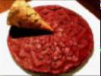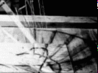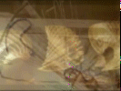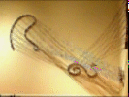

Phases of the Vessel
This photographic series was inspired by the Sixteenth century Kabbalist, Isaac Lurria and his explanation of the creation of the Universe. I quote now from The Power of Kabbalah, an audio series based on the teachings of Rav Berg: “He described the essential energy of the light force of the Creator as being sharing or giving. In the beginning, a vessel was required to receive this light force; the sharing of that light force was infinite and limitless, a constant giving and receiving was being exchanged. Kabbalah teaches that the primordial soul of humanity was contained within the original vessel. When the vessel received the light force, it also received some of the attributes of the Creator, so like the Creator, it also was driven to share and give the light force. At that point, the vessel said, “stop,” and the Creator responded by immediately retracting the light force and didn’t share its light with the vessel anymore. At that moment the vessel which created all the soul of humankind shattered into an infinite number of smaller vessels, creating time, space, motion, and the physical Universe as we know it.”
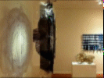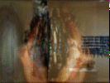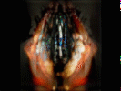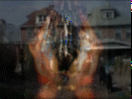

11 Veils
Phase 111 Veils began when our country went to war. I thought it was awesome how many yellow ribbons were everywhere in unity, representing that the soldiers were missed and loved. It was amazing how this happened across every community in this country. Whether you were for the war or not, we all felt compassion for our soldiers.
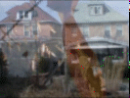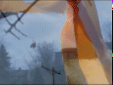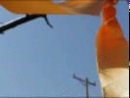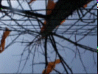

Phase 2
It is all viewpoints. One can see the world from inside or outside. Which is the restriction? What side do you enter from? Consider all the sensual information coming into you that influences your viewpoint.
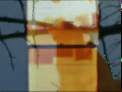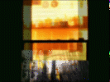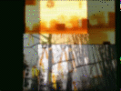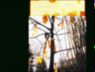

Phase 3
I’ve printed the previous photographic series on transparencies as a model for a sculpture installation. The picture planes are parallel. The repetition and transition between layers creates new groupings of forms and spatial perspectives. I love the ability of the camera to capture these instantaneous compositions and freeze them in time.
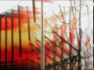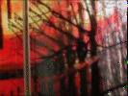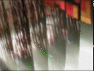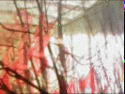

Phase 4
These are images of the 11 Veils sculpture installed at PPG Wintergarden in Pittsburgh. The Oak branches and ribbons are from the same tree that is in the photographs. The sculpture becomes a physical presence in relation to the body, reflecting a metaphysical idea.
The 11 are for ten dimensions plus one. I like to think of the ten dimensions as The Ten Sfirot - Emanations: “To conceal the blinding Light of the Upper World, and thus create a tiny point into which our universe would be born, ten curtains were fabricated. These curtains are called Ten Sfirot. Each successive Sfirah further reduces the emanation of Light, gradually dimming its brilliance to a level almost devoid of Light – our physical world known as Malchut. The only remnant of Light remaining in this darkened universe is a pilot light, which sustains our existence. This Light is the life force of a human being and the force that gives birth to stars, sustains suns and sets everything from swirling galaxies to busy anthills in motion. Moreover, the Ten Sfirot act like a prism, refracting Light into many colors giving rise to diversity of life and matter in our world.” – Zohar
The extra veil is the portal, the point of view from which one sees.
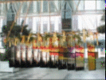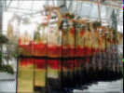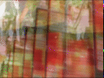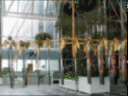

Phase 5
Here the 11 Veils sculpture is installed in the Terminal Buildings in Pittsburgh for an art exhibition. The work has a completely different presence in this factory environment as compared with the previous clip where the space is open to the sky.
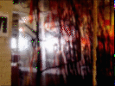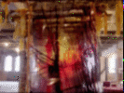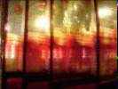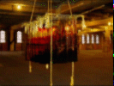

Prayer Flags
I was looking into Tibetan Mandalas and Prayer Flags, and have become intrigued with their ephemeral profundity. The Buddhist Monks create intricate Mandalas of sand devoting hours to delicate detail and deep meditation, only to be concluded by a scattering and dissolution of the work through ceremoniously recycling it back into the environment.

Phase 1
The first phase of the Prayer Flags project was the paintings. I painted on a curtains taped to the computer monitor over close up photographs that I had taken of a flesh colored iris. The iris is both figurative in its coloring and form. The iris also symbolizes the rainbow, the bridge between heaven and earth.
It was interesting to see the light of the monitor as it was obscured and revealed by the paint. Light would become dark and dark would become light. Upon completion of the painting experience, the veil curtain painting was removed and the monitor painting was revealed. I photographed the monitor paintings and wiped them away to begin again.
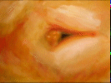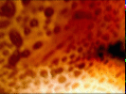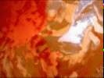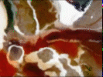

Phase 2A
The Prayer Flags were also installed in the Terminal Buildings art exhibition. The meaning implied by context is quite somber in the factory setting. Compare this with the following next clip, which is photographed in an outdoor location.
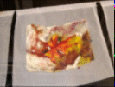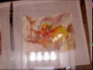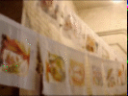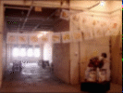

Phase 2
The veils or flags are transparent or opaque depending upon the paint that remains on them and how the light and wind travel through them. The wind is blowing through and carrying messages embedded within the markings of pigment, carrying with it the labor of love with which the paintings were conceived and created. The project itself is a meditation and a prayer.
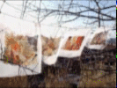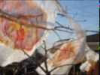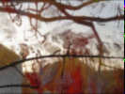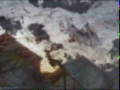

Shadow Puppets

Phase 1
This project series explores Plato’s Allegory of the Cave, which is an archetypical theme that has been expressed in many myths and stories throughout time. A particular rendition of this theme is a story by the Russian author Sologube. A child mysteriously finds a small booklet of shadow puppet figures. He becomes engrossed in creating these figures with his hands upon the wall. He becomes so obsessed that his studies suffer, and he begins to shirk his household chores. His mother discovers the book is the source of his distraction and she confiscates it. Still the obsession continues. Curious, the mother opens the book and begins to look inside. Needless to say, she becomes obsessed too. Both mother and son become enveloped in their obsessions with the shadow figures. Soon all other things fall away, there they are, mother and son communicating in the language of the shadow figures, transported from this world into the realm of light and shadow.
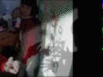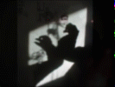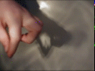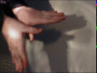

Phase 2
The clustering and grouping of these sprout forms create a very animated field. To me they become very figurative in the way that each has a unique gesture and context within the mass of living form. I scanned clover sprouts, the salad type, on my flat bed scanner to create the initial image. I then worked this image into paintings, carvings, woodblock prints and digital prints. Within each embodiment of the form I tried to express through the media this “anima” that is within the living sprouts.
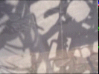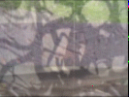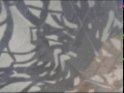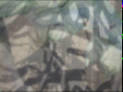

Conclusion/Aither
The goal of Alchemy is not the physical gold of purification of physical baser metals, but the purification of the soul, a communion with the Aither. Freud expressed this in psychological terms as the Oceanic Feeling. The two works shown here explore the idea of transcendence of the material world to become part of the Universal Consciousness, the Anima Mundi. The figurative work Aither is made of digital prints and sticks. This work is still in progress. The concluding work “Moss Hammock” is the oldest work I’ve shown. I’ve chosen to conclude with the juxtaposition of a work made before I ever touched a computer, Moss Hammock, with my most recent project, Aither. Here you can see how themes and visions become circular, no matter what the medium. It is all smoke and mirrors. The key is to love the journey.
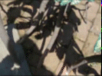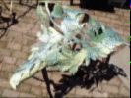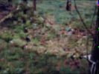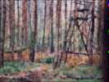
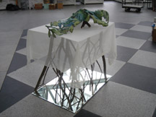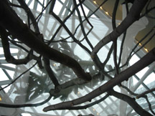

"Aither: We Are All Made of Stars" is currently on display in The Pittsburgh Society of Sculptors University Exhibition at the PPG Wintergarden, 1 PPG Place, Pittsburgh, PA.

